DEPARTMENT of VETERANS AFFAIRS ADVANCED FELLOWSHIPS
in MENTAL ILLNESS RESEARCH and TREATMENT
  - South Central VA Mental Illness, Research, and Education Center
and Central Arkansas Veterans Healthcare System
  - North Little Rock, Arkansas

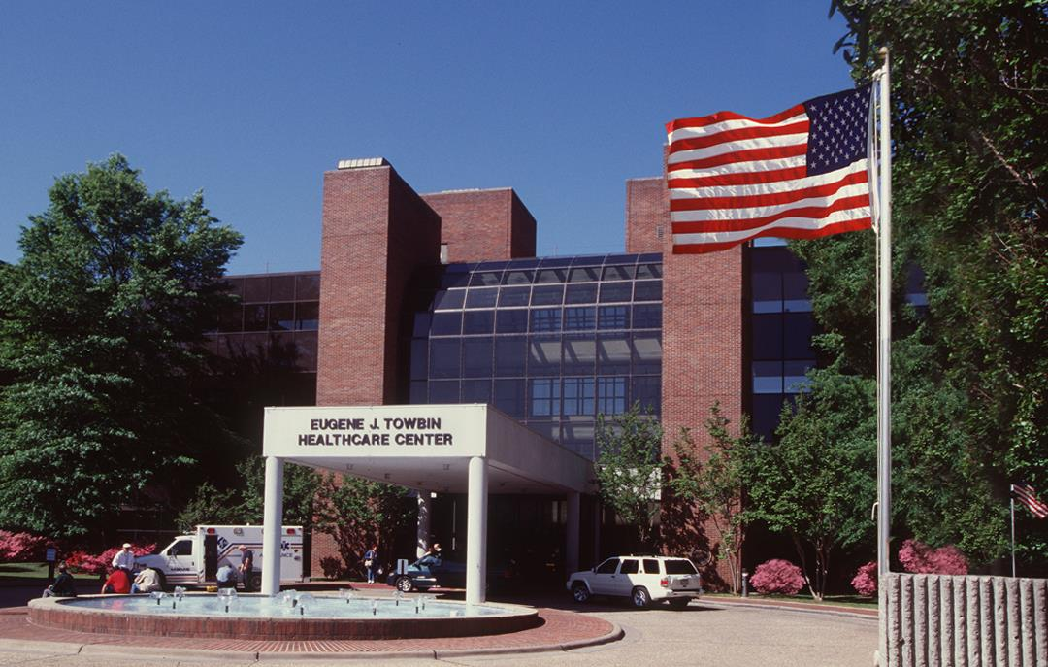
Call for Applications 2020-2022— VA Advanced Fellowship Program in Mental Illness Research and Treatment

Overview
Applications are currently being accepted for the SC MIRECC Advanced Fellowship Program in Mental Illness Research and located in Little Rock, Arkansas. Practitioners including psychologists, pharmacists, nurses, and social workers are eligible to apply. This fellowship is a two-year research training program (75% time devoted to research and 25% to advanced clinical training). The SC MIRECC’s mission is to promote equity in engagement, access, and quality of mental healthcare to Veterans facing barriers to care, especially rural Veterans. The purpose of the fellowship is to train health care professionals for future leadership roles in research, education, and clinical services, particularly in academic and medical care settings such as VA. Although many Fellows pursue careers focused predominantly on academic research and education in mental health, successful graduates of the program also pursue leadership careers that emphasize education and clinical contributions in mental health.
By the end of the fellowship program, Fellows should be ready to pursue entry-level leadership roles, which integrate state-of-the-art research, education, and clinical approaches to mental health in the VA healthcare system and other settings. Fellows pursuing academic clinical-research careers should also be ready to submit applications for career development awards (such as VA Career Development Awards or NIH K-Awards) toward the end of their fellowship.

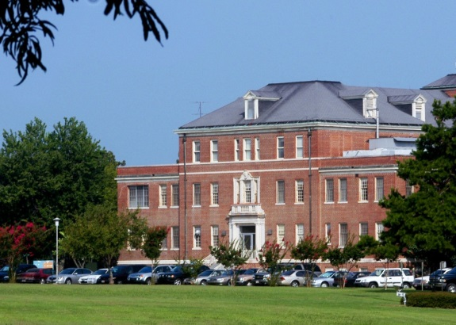
Research Mentoring
The SC MIRECC fellowship is located in building 58 at CAVHS.
The Little Rock SC MIRECC Fellowship is founded upon a team mentoring approach where each Fellow works with a primary mentor and a team of research and clinical advisors. Senior research faculty and interests include:
Michael A. Cucciare, PhD: Implementation of evidence-based treatments; computer-based technology in mental health treatment; treatments for substance use disorders
Geoffrey Curran, PhD: Implementation science; qualitative methods; substance use disorders
Ellen Fischer, PhD: Rural populations’ access to treatment; family involvement in care for PTSD and schizophrenia; outcomes of care
Teresa Hudson, PhD, PharmD: Use of large epidemiologic databases to study access and quality of care; opioid use and risk factors for misuse/abuse; rural/urban disparities in care
JoAnn Kirchner, MD: Implementation science; implementation of evidence-based practices in clinical settings; primary care mental health integration
Sara Landes, PhD: Implementation science; suicide prevention; dialectical behavior therapy
Richard Owen, MD: Schizophrenia; depression; management of antipsychotic drug side effects; implementation science; quality of care
Jeffrey Pyne, MD: Telemedicine; PTSD; psychophysiological assessment; virtual reality; substance use disorders; cost-effectiveness analyses; mental health-clergy collaboration

Academic and Cultural Environment
Central Arkansas Veterans Healthcare System is a large and complex VA Medical System, with two large medical facilities in the Little Rock metropolitan area of about 580,000 people. CAVHS also has community-based outpatient clinics (CBOCs) throughout the state of Arkansas to serve its large rural population of Veterans. In addition to the SC MIRECC, CAVHS hosts four other VA research centers: the HSR&D Center for Mental Healthcare and Outcomes Research (CeMHOR), the Behavioral Health Quality Enhancement Research Initiative (BH QUERI), the Partnered Evaluation of the Social Determinants of Health and Healthcare Resource Needs of Rural Veterans, and the Little Rock Geriatric, Research, Education, and Clinical Center (GRECC). The academic affiliate is the University of Arkansas for Medical Sciences (UAMS). Fellows receive an appointment as Instructor and are involved in the academic activities of UAMS faculty in the Center of Health Services Research within the Department of Psychiatry.
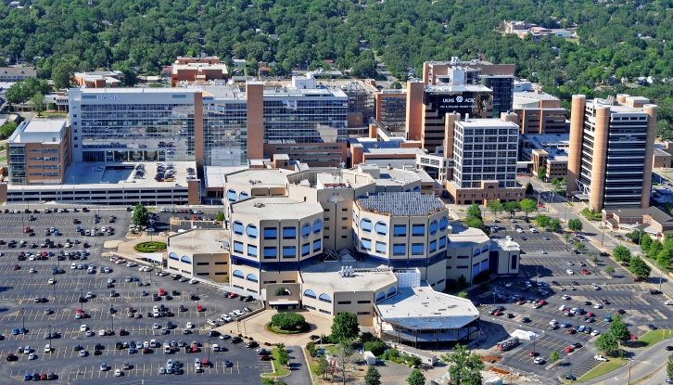
Arkansas, “the Natural State,” offers a multitude of scenic landscapes along with natural and cultural resources and programs. Little Rock, the state capitol, has many excellent restaurants, a thriving cultural community, museums, public golf courses, Pinnacle Mountain State Park, and the 17-mile Arkansas River Trail for walking, jogging, and cycling. Arkansas has a large state park system with campsites, hiking trails, mountain lodges, interpretive events, fall foliage programs, and activities for all seasons.
The Little Rock campus of CAVHS (front center) and the campus of UAMS (rear center).

Clinical Training Opportunities
Working with their mentoring team, Fellows will develop a set of practice experiences that best complement their research and career goals and accrue sufficient hours for licensure. Clinical supervisors include national VA training experts for evidence-based psychotherapies. Recent fellows have completed clinical rotations related to trauma recovery, anxiety and depression treatment, women’s health, telemedicine, substance use disorder treatment, primary care mental health, and rehabilitation psychology.

Stipend and Benefits
- Full-time stipend of $46,102 (for the 1st year), beginning late summer or early fall 2019; stipend amount may change; small increase for second year
- Vacation (13 days per year) and Sick leave (13 days per year)
- Benefits as applicable including eligibility for health insurance
- Authorized leave for professional conferences (limited travel funds usually available)
- $7,000 in research and start-up funds
- Tuition support for courses at UAMS
- $1,000 in books and supplies

Requirements
- Must be a U.S. citizen
- Eligible psychologist must have graduated from an American Psychological Association (APA) or Canadian Psychological Association (CPA) accredited doctoral program in clinical/counseling psychology and are enrolled or completed an APA or CPA-accredited internship
- For the eligibility requirements for other health care disciplines, please contact Kristin Ward (see below)
- Doctoral requirements must be completed before fellowship start date
- Fellowship preferred start date is flexible (usually between July 1 and September 15)
- Applications received by December 15, 2019 will be given priority; applications may be accepted until positions are filled
- Interested applications are encouraged to contact Dr. Michael Cucciare (see below)

Application Procedure
Please submit the following by email or postal mail:
- Cover Letter describing
  - Area(s) of research interest and how this training will advance your career
  - Research training and goals
  - Clinical experience and goals
- Curriculum Vitae – including description of your internship rotations
- Three Letters of Recommendation addressed to Dr. Michael Cucciare, Director of the SC MIRECC Advanced Research Fellowship (such as from training directors or research and clinical supervisors familiar with your work)
- Official graduate school transcripts (sent directly by your university)
- Two or three samples of scholarly writing, such as an executive summary of your dissertation, journal publication, or research manuscript
Specific information about by-invitation interviews will be sent to qualified applicants.
Note: VA fellows are subject to all employment rules applying to federal employees, including selective service registration if applicable. The United States Government does not discriminate in employment based on race, color, religion, sex, national origin, political affiliation, sexual orientation, gender identity, marital status, disability and genetic information, age, membership in an employee organization, or other non-merit factor.
This fellowship is currently not accredited by the American Psychological Association. The program is currently preparing the documentation required for accreditation consideration.

Contact Us
Please direct questions about the Advanced Fellowship Program at CAVHS and application process to
Ms. Kristin Ward (see contact information below) or to Dr. Michael A. Cucciare (michael.cucciare@va.gov).
Administrative Contact/Submission of Materials:
Kristin Ward
South Central MIRECC
2200 Fort Roots Drive, 16MIR
N. Little Rock, AR 72114-1706
501-257-1236
kristin.ward2@va.gov

Other Information
CAVHS also hosts a one-year clinical fellowship program with emphasis areas in psychosocial rehabilitation and recovery and in PTSD. For information about the clinical fellowship, please visit the website:
http://www.littlerock.va.gov/careers/psychology/fellowship/Psychology_Fellowship_Prgram.asp

